Unit 3 Links to Kahoots and Unit Tests
Type of Division | https://create.kahoot.it/share/types-of-division-review/7c4b9298-1bc7-4ca7-9c85-050933c2ef3b
Mission 9 | https://create.kahoot.it/share/firia-labs-mission-9/6d47a695-09a7-49f0-ac44-fce2d24f7fb1

Types of Division Kahoot Review
What are the possible values of ‘num’?  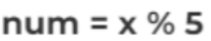 | - 0, 1  - 1, 2, 3, 4, 5  - 0, 1, 2, 3, 4  - All integers
What are the possible values of ‘num’?  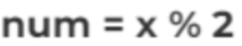 | - 0, 1  - 1, 2  - 0, 1, 2  - All integers
Evaluate 7 / 4 = | - 1  - 0.75  - 3  - 1.75
Evaluate 7 // 4 = | - 1  - 0.75  - 3  - 1.75
Evaluate 7 % 4 == | - 1  - 0.75  - 3  - 1.75

Mission 9 Kahoot Review
What are the possible values of ‘num’?  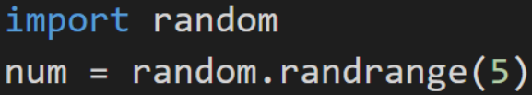 | - 1, 2, 3, 4, 5  - 0, 1, 2, 3, 4  - 0, 1, 2, 3, 4, 5  - -5 through +5
What value is assigned to ‘color’?  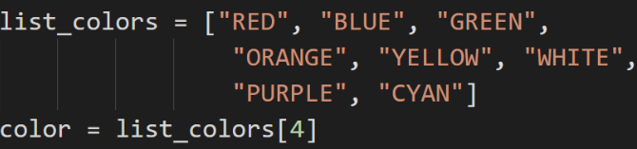 | - YELLOW  - ORANGE  - WHITE  - Index out of range error
Which code has the correct indenting?

This code is an example of:  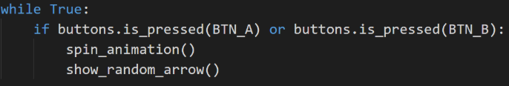 | - Function  - Parameter  - Logical operator  - Control variable
When will the loop stop?  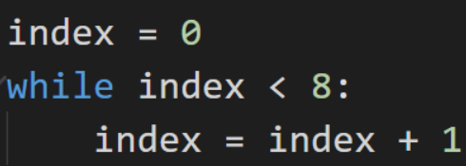 | - When ‘index’ reaches 8  - When ‘index’ reaches 7  - When ‘index’ reaches 0  - When ‘index’ is incremented
How many times will the loop execute?  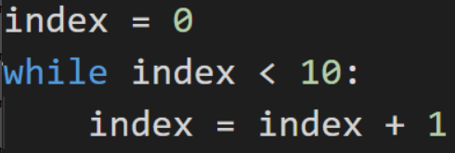 | - 1 time  - 9 times  - 10 times  - Infinite loop
The value 3 is an example of:  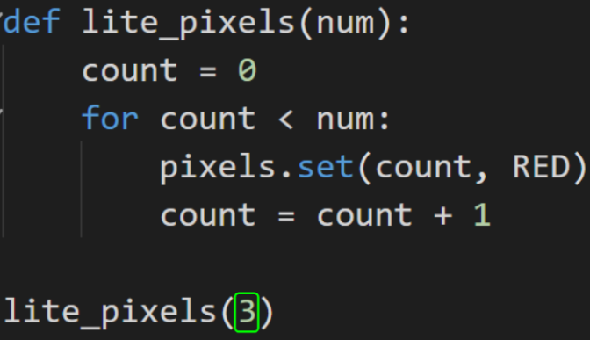 | - A function definition  - A parameter  - An argument  - A loop control variable
The variable ‘num’ is an example of:  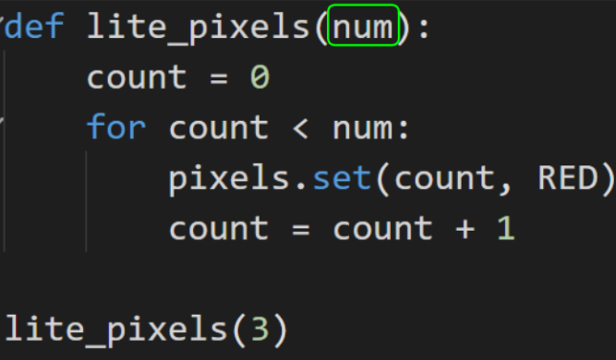 | - A function definition  - A parameter  - An argument  - A loop control variable
The variable ‘count’ is an example of:  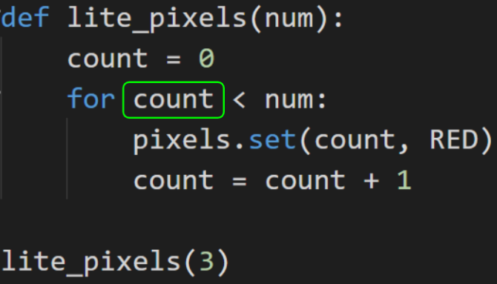 | - A function definition  - A parameter  - An argument  - A loop control variable
The highlighted code is an example of:  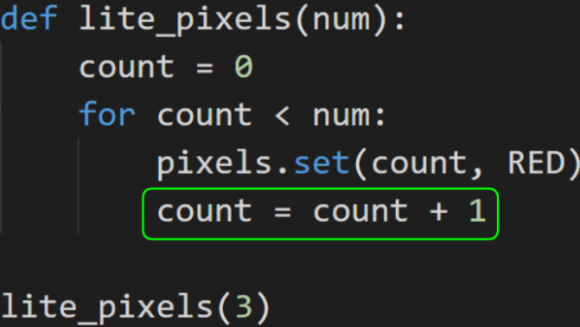 | - A function definition  - Increment a control variable  - A parameter  - A loop control variable
The highlighted code is an example of:  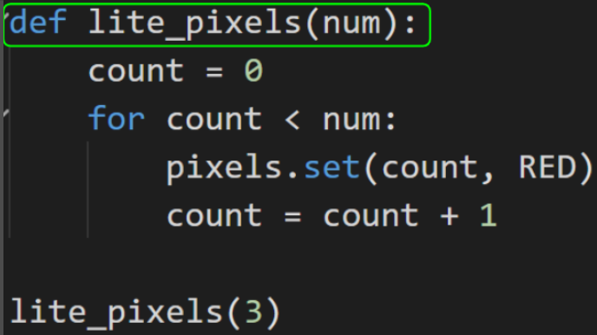 | - A function definition  - Increment a control variable  - A function call  - A loop control variable
The highlighted code is an example of:  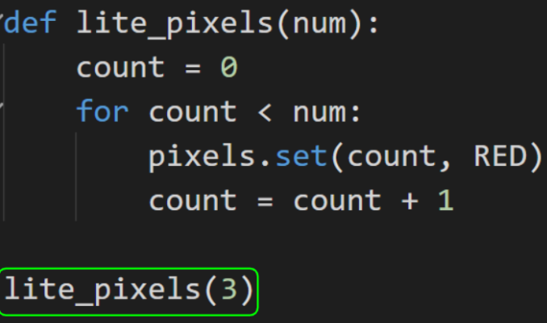 | - A function definition  - Increment a control variable  - A function call  - A loop control variable
What code correctly defines a function? | - def lite_pixels(num):  - def lite_pixels(3)  - lite_pixels(3)  - lite_pixels(num):
What code correctly calls a function? | - def lite_pixels(num):  - def lite_pixels(3)  - lite_pixels(3)  - lite_pixels(num):
What variable is the loop control variable?  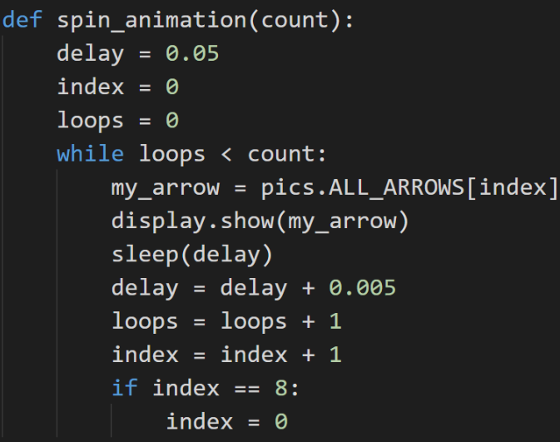 | - delay  - index  - loops  - count

Unit 3 Question Bank: Vocabulary
Select the best computer science definition for each vocabulary word
Logical operator | - The condition that controls a loop  - A way to loop through a list  - Operators that handle combinations of Boolean results: and / or  - Operators that create a Boolean expression: <, >, ==
Function | - A type of iteration with a loop  - A named chunk of code you can run anytime by calling it  - A type of selection with an if statement  - A way to input information by pressing a button
Argument | - The value passed into a function - information needed to complete a task  - A read-only version of a list  - A variable in a function that gets a value when the function is called  - A variable that exists only inside a function
Parameter | - The value passed into a function - information needed to complete a task  - A read-only version of a list  - A variable in a function that gets a value when the function is called  - A variable that exists only inside a function
Local variable | - The value passed into a function - information needed to complete a task  - A read-only version of a list  - A variable in a function that gets a value when the function is called  - A variable that exists only inside a function
Tuple | - The value passed into a function - information needed to complete a task  - A read-only version of a list  - A variable in a function that gets a value when the function is called  - A variable used in a condition that determines when a loop will end
Control variable | - The value passed into a function - information needed to complete a task  - A variable in a function that gets a value when the function is called  - A local variable in a function that gets a value when the function is called  - A variable used in a condition that determines when a loop will end
Decimal division | - Division problem where the answer is a real number  - Division problem with two answers: the integer and the remainder  - The remainder of a long division problem  - Division problem where the answer is a whole number only
Integer division | - Division problem where the answer is a real number  - Division problem with two answers: the integer and the remainder  - The remainder of a long division problem  - Division problem where the answer is a whole number only
Modulo division | - Division problem where the answer is a real number  - Division problem with two answers: the integer and the remainder  - The remainder of a long division problem  - Division problem where the answer is a whole number only
Traverse | - Defining and calling a function  - Traveling through a list one element at a time  - A list of lists  - Executing code one line at a time
Matrix | - A read-only version of a list  - Traveling through a list one element at a time  - A list of lists  - Executing code one line at a time
Procedural abstraction | - A named set of instructions that accomplishes a task  B. A technique that breaks down complex tasks into smaller tasks  C. A technique that simplifies complex information, making data easier to manage and use  D. A sequence of items you can access with an index.
Data abstraction | - A named set of instructions that accomplishes a task  B. A technique that breaks down complex tasks into smaller tasks  C. A technique that simplifies complex information, making data easier to manage and use  D. A sequence of items you can access with an index.

Unit 3 Question Bank: Concepts and Coding
The code is an example of:  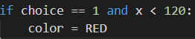 | - Function  - Parameter  - Control variable  - Logical operator
When will the loop stop?  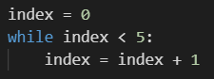 | - When index = 5  - When index = 4  - When index = 6  - When index is incremented
How many times will the loop execute?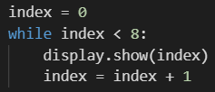 | - 1 time  - 7 times  - 8 times  - Infinite loop
The highlighted code is an example of:  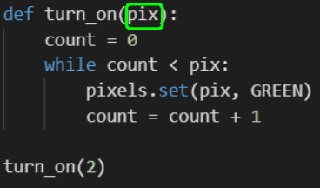 | - A function definition  - A function call  - An argument  - A parameter
The highlighted code is an example of:  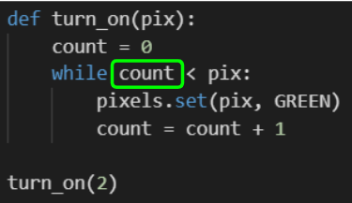 | - A loop control variable  - A function call  - An argument  - A parameter
The highlighted code is an example of:  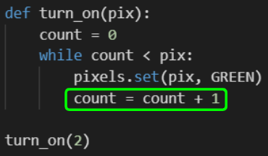 | - A loop control variable  - Increment a control variable  - An argument  - A parameter
The highlighted code is an example of:  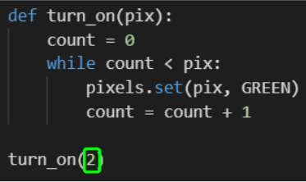 | - A function definition  - A function call  - An argument  - A parameter
The highlighted code is an example of:  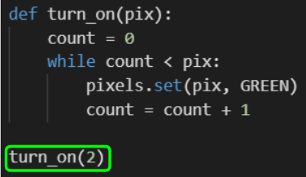 | - A function definition  - A function call  - An argument  - A parameter
The highlighted code is an example of:  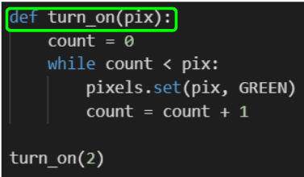 | - A function definition  - A function call  - An argument  - A parameter
What variable is the loop control variable?  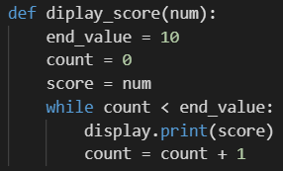 | - num  - end_value  - score  - count
What code correctly defines a function with a parameter? | - def turn_on(pix):  - def turn_on(3)  - turn_on(3)  - turn_on(pix):
What code correctly calls a function with a parameter? | - def turn_on(pix):  - def turn_on(3)  - turn_on(3)  - turn_on(pix):
Which of the following code segments is an example of using ‘color’ as a parameter? | - B. 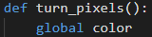  C. 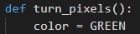 D.
Which of the following code segments is an example of using ‘color’ as an argument? | - B.  C. D.
Which of the following code segments is an example of using ‘color’ as a local variable? | - B.  C. D.
Which line of code correctly calls a function, given this function definition. | - turn_pixels(RED, 50)  - turn_pixels(RED, 50, 0.5)  - turn_pixels(color, brightness, delay):  - turn_pixels(delay, brightness, color)
The highlighted code is an example of:  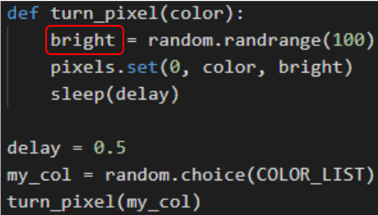 | - Parameter  - Argument  - Local variable  - Global variable
The highlighted code is an example of:  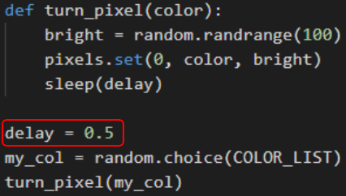 | - Parameter  - Argument  - Local variable  - Global variable
The highlighted code is an example of:  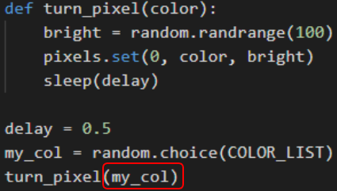 | - Parameter  - Argument  - Local variable  - Global variable
The highlighted code is an example of:  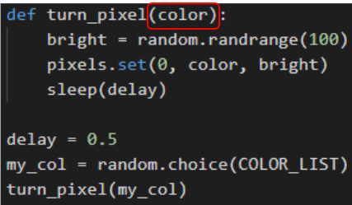 | - Parameter  - Argument  - Local variable  - Global variable
All the following are reasons to use a parameter EXCEPT: | - It is used as a loop control variable  - It is used as an argument for a built-in function  - It is used to calculate another value  - It is used in a comparison
Given this code segment, what are the values of ‘index’?  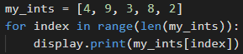 | - 4, 9, 3, 8, 2  - 5  - 0, 1, 2, 3, 4  - 0
Given this code segment, what are the values of ‘index’?  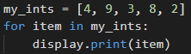 | - 4, 9, 3, 8, 2  - 5  - 0, 1, 2, 3, 4  - 0
Which code segment will display the names in the list on CodeX? | - 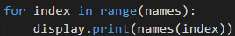  - 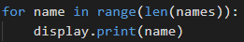  - 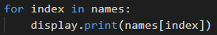  - 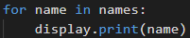
Which code segment will repeatedly display names from the list ‘count’ times? | - 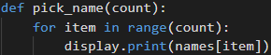  - 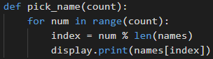  - 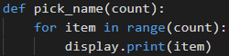  - 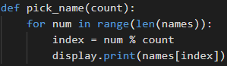
Which code segment correctly defines a matrix? | - 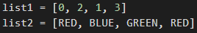  - 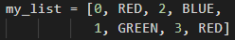  - 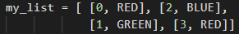  - 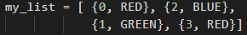
Which code segment correctly traverses a matrix? | - 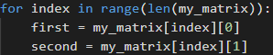  - 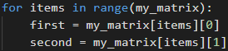  - 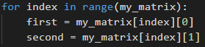  - 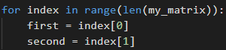
What does this code segment do?  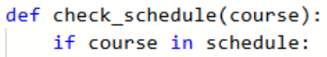 | - Checks to see if ‘schedule’ is an element of the list ‘course’  - Checks to see if ‘course’ is an element of the list ‘schedule’  - Traverses the list ‘course’ and prints the schedule  - Traverses the list ‘schedule’ and prints each course
What does this code segment do? | - Appends a new course to the list  - Assigns to ‘course’ an integer typed in the Console  - Assigns to ‘course’ the text that is typed in the Console  - Assigns to ‘course’ the value “Enter a class:”
What does this code segment do? | - Appends a new course to the list  - Assigns to ‘course’ an integer typed in the Console  - Assigns to ‘course’ the text that is typed in the Console  - Assigns to ‘course’ the value “Enter a class:”
What does this code segment do?  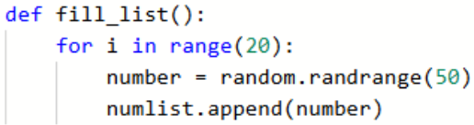 | - Append 20 random numbers between 1 and 50 to the list  - Append 20 random numbers between 0 and 49 to the list  - Append 50 random numbers between 0 and 20 to the list  - Append the numbers 1 through 50 to the list
What does this code segment do?  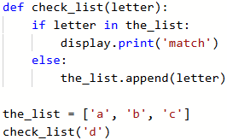 | - Displays ‘no match’ on the CodeX screen  - Displays ‘match’ on the CodeX screen  - Appends the letter to the_list  - First displays ‘match’ and then appends the letter to the_list
What does this code segment do?  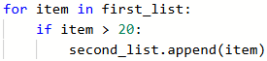 | - Has a syntax error and will not run  - Creates second_list, which is the same as first_list  - Creates a second_list with items from first_list that are less than 20  - Creates a second_list with items from first_list that are more than 20
What line of code will display the number 20 on the CodeX screen? | - print(20)  - display.print(20)  - display.print(int(20))  - display.print(str(20))
Which statement is NOT a reason to traverse a list? | - Display all items in a list one at a time  - Display random items in a list a given number of times  - Look through a list to see if a specific value is in the list  - Create a filtered list

